NAME : Shri Harshini Devi . A
REG.NO : 192524104
Dept. Name : CSE -AIDS
Course Code/Course Name: DSA06 /Data Handling and Visualization
Date: 15/07/2026

LIST OF EXPERIMENTS

Set 1: Monthly Sales Data
Dataset: Monthly Sales
1. Create a line chart to visualize the monthly sales. Label the axes and title the chart appropriately.

# Monthly Sales Data
month <- c("Jan", "Feb", "Mar", "Apr", "May", "Jun",
"Jul", "Aug", "Sep", "Oct", "Nov", "Dec")

sales <- c(120, 150, 180, 170, 210, 250,
240, 270, 300, 320, 350, 400)

# Create Line Chart
plot(sales,
type = "o",
xaxt = "n",
xlab = "Month",
ylab = "Sales",
main = "Monthly Sales",
col = "blue",
pch = 16,
lwd = 2)

# Add Month Labels
axis(1, at = 1:12, labels = month)

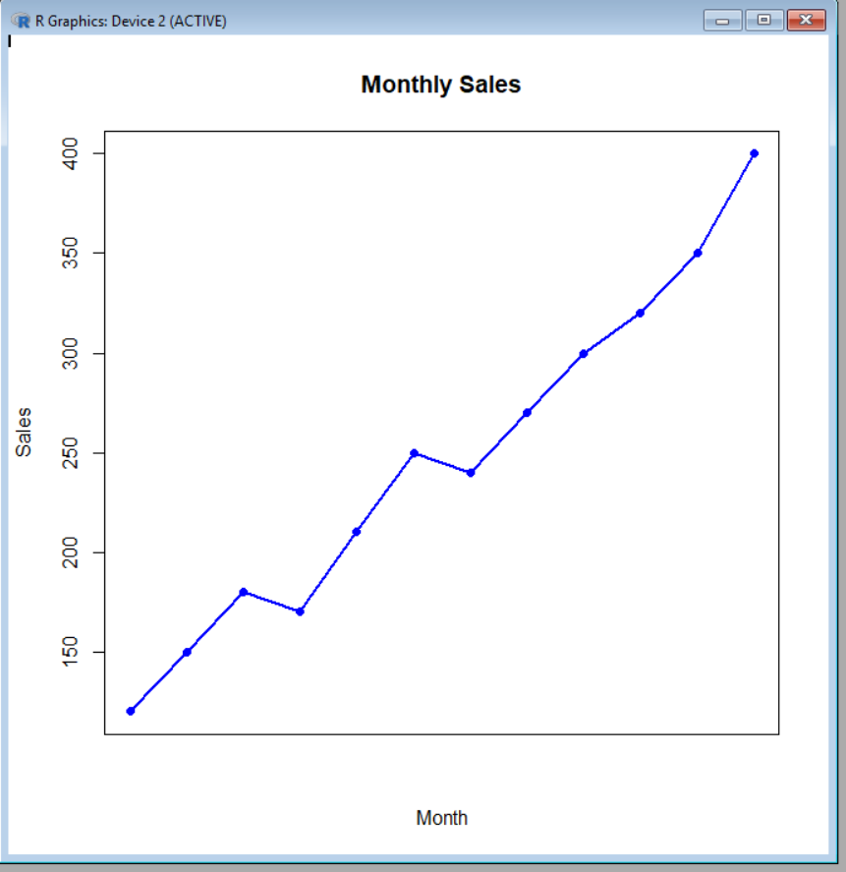

2. Generate a bar chart to display the top-selling products for the year. Label the chart elements.

# Product Sales Data
products <- c("Product A", "Product B", "Product C", "Product D", "Product E")
sales <- c(500, 700, 450, 650, 800)

# Create Bar Chart
barplot(sales,
names.arg = products,
col = "skyblue",
main = "Top-Selling Products for the Year",
xlab = "Products",
ylab = "Sales",
border = "black")

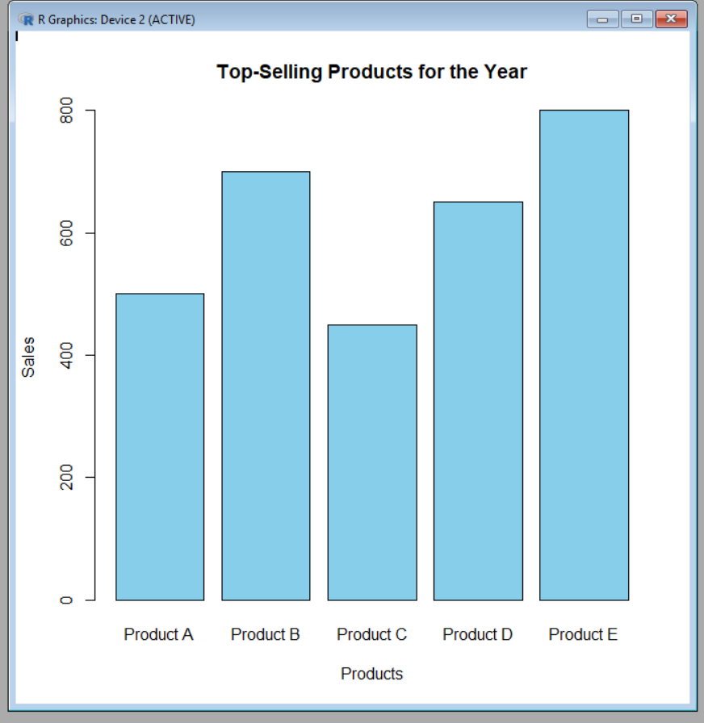
3. Develop a scatter plot to explore the relationship between advertising budget and monthly sales.
Explain the insights drawn from the scatter plot.

# Advertising Budget and Monthly Sales Data
advertising <- c(10, 15, 20, 18, 25, 30, 28, 35, 40, 42, 45, 50)
sales <- c(120, 150, 180, 170, 210, 250, 240, 270, 300, 320, 350, 400)

# Create Scatter Plot
plot(advertising, sales,
main = "Advertising Budget vs Monthly Sales",
xlab = "Advertising Budget",
ylab = "Monthly Sales",
pch = 16,
col = "blue")

# Add Trend Line
abline(lm(sales ~ advertising), col = "red", lwd = 2)

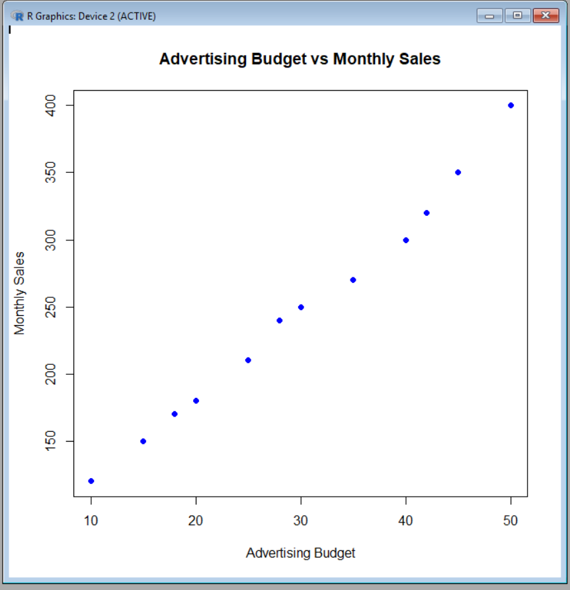

4. Build an interactive dashboard combining the line chart and bar chart to allow users to explore
sales data interactively.

# Install packages (Run only once)
# install.packages("flexdashboard")
# install.packages("plotly")

library(flexdashboard)
library(plotly)

# Monthly Sales Data
month <- c("Jan","Feb","Mar","Apr","May","Jun",
"Jul","Aug","Sep","Oct","Nov","Dec")
sales <- c(120,150,180,170,210,250,240,270,300,320,350,400)

# Product Sales Data
products <- c("Product A","Product B","Product C","Product D","Product E")
product_sales <- c(500,700,450,650,800)

# Line Chart
line_chart <- plot_ly(
x = month,
y = sales,
type = "scatter",
mode = "lines+markers"
) %>%
layout(
title = "Monthly Sales",
xaxis = list(title = "Month"),
yaxis = list(title = "Sales")
)

# Bar Chart
bar_chart <- plot_ly(
x = products,
y = product_sales,
type = "bar"
) %>%
layout(
title = "Top-Selling Products",
xaxis = list(title = "Products"),
yaxis = list(title = "Sales")
)

# Display Dashboard
subplot(line_chart, bar_chart, nrows = 2, shareX = FALSE)

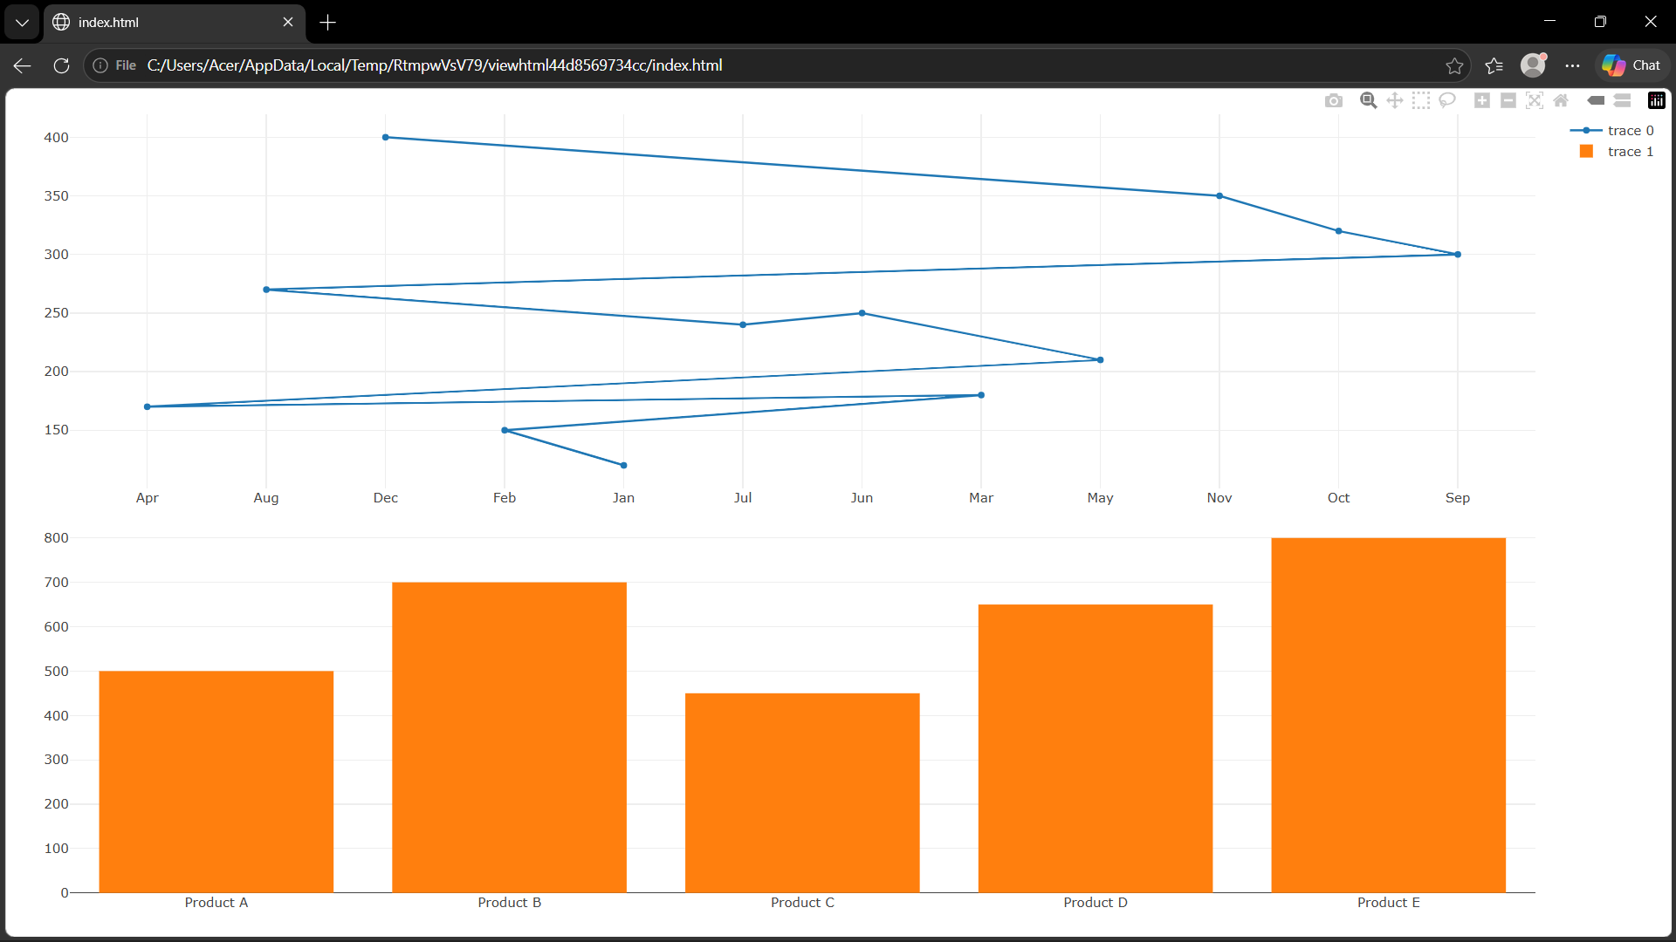

Set 2:
- Create a histogram to represent the distribution of customer ages. Label the axes and title the chart.
# Customer Age Data
age <- c(25, 30, 35, 28, 40)

# Create Histogram
hist(age,
main = "Distribution of Customer Ages",
xlab = "Age",
ylab = "Frequency",
col = "lightblue",
border = "black",
breaks = 5)
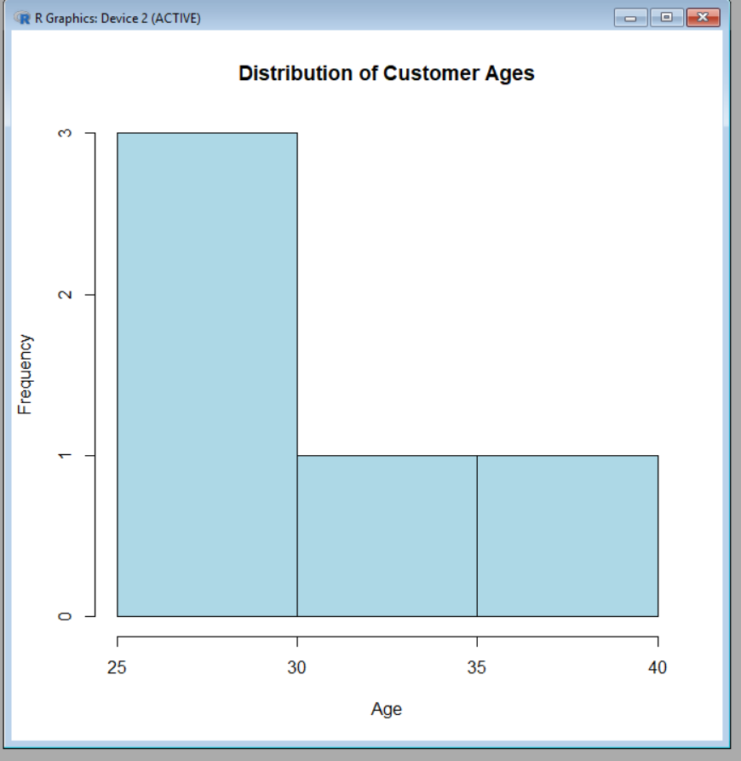
- Generate a pie chart to display the overall distribution of customer satisfaction scores. Include labels.

# Customer Satisfaction Scores
satisfaction <- c(4, 5, 3, 4, 5)

# Count the frequency of each score
score_count <- table(satisfaction)

# Create Pie Chart
pie(score_count,
labels = paste(names(score_count), "Stars"),
main = "Customer Satisfaction Score Distribution",
col = rainbow(length(score_count)))

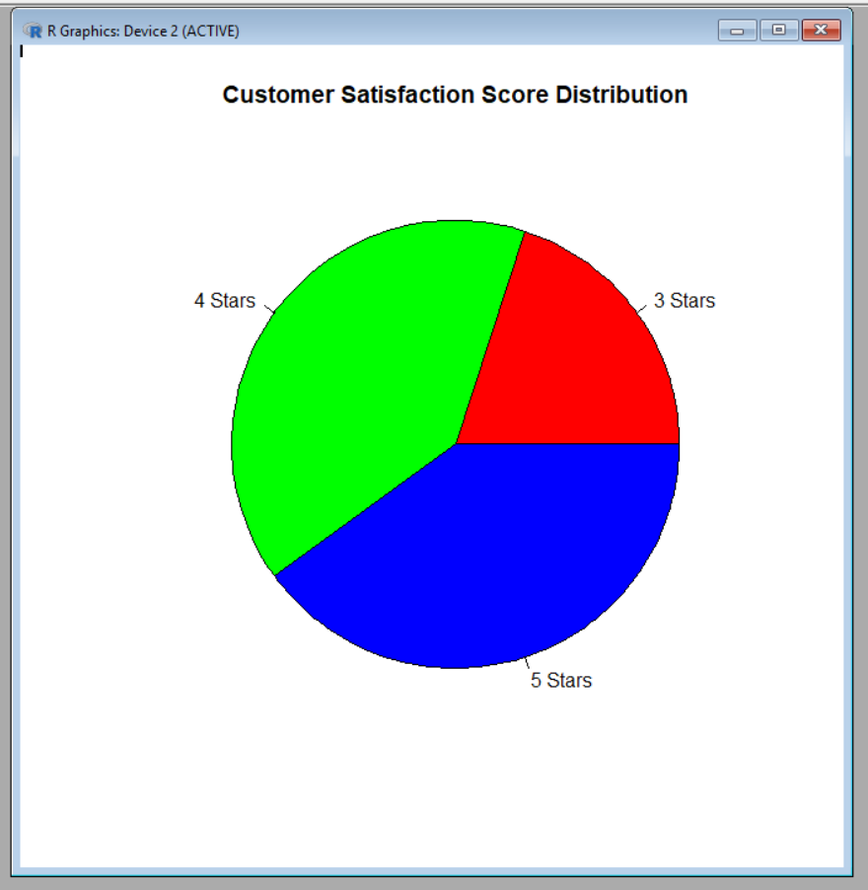
- Build a stacked bar chart to visualize the distribution of customer satisfaction scores by age group.

# Customer Data
age <- c(25, 30, 35, 28, 40)
satisfaction <- c(4, 5, 3, 4, 5)

# Create Age Groups
age_group <- c("20-29", "30-39", "30-39", "20-29", "40-49")

# Create Frequency Table
data <- table(age_group, satisfaction)

# Stacked Bar Chart
barplot(data,
main = "Customer Satisfaction by Age Group",
xlab = "Age Group",
ylab = "Number of Customers",
col = c("lightblue", "lightgreen", "pink"),
legend = rownames(data))

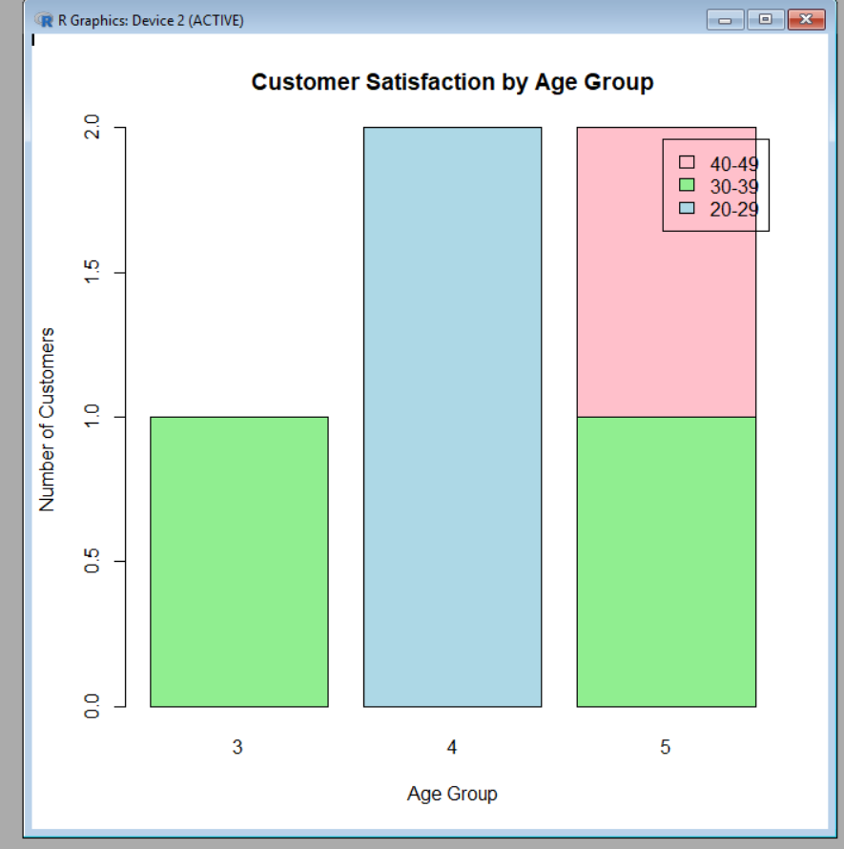
- Develop a word cloud from open-ended customer feedback to identify prevalent customer sentiments.

# Install packages (Run only once)
install.packages("wordcloud")
install.packages("tm")

# Load libraries
library(wordcloud)
library(tm)

# Sample Customer Feedback
feedback <- c(
"Excellent service",
"Good quality product",
"Fast delivery",
"Excellent support",
"Good experience"
)

# Create Corpus
corpus <- Corpus(VectorSource(feedback))

# Convert to plain text
corpus <- tm_map(corpus, content_transformer(tolower))
corpus <- tm_map(corpus, removePunctuation)
corpus <- tm_map(corpus, removeNumbers)
corpus <- tm_map(corpus, removeWords, stopwords("english"))

# Create Term Document Matrix
tdm <- TermDocumentMatrix(corpus)
m <- as.matrix(tdm)
words <- rownames(m)
freq <- rowSums(m)

# Generate Word Cloud
wordcloud(words, freq,
min.freq = 1,
colors = rainbow(length(words)))

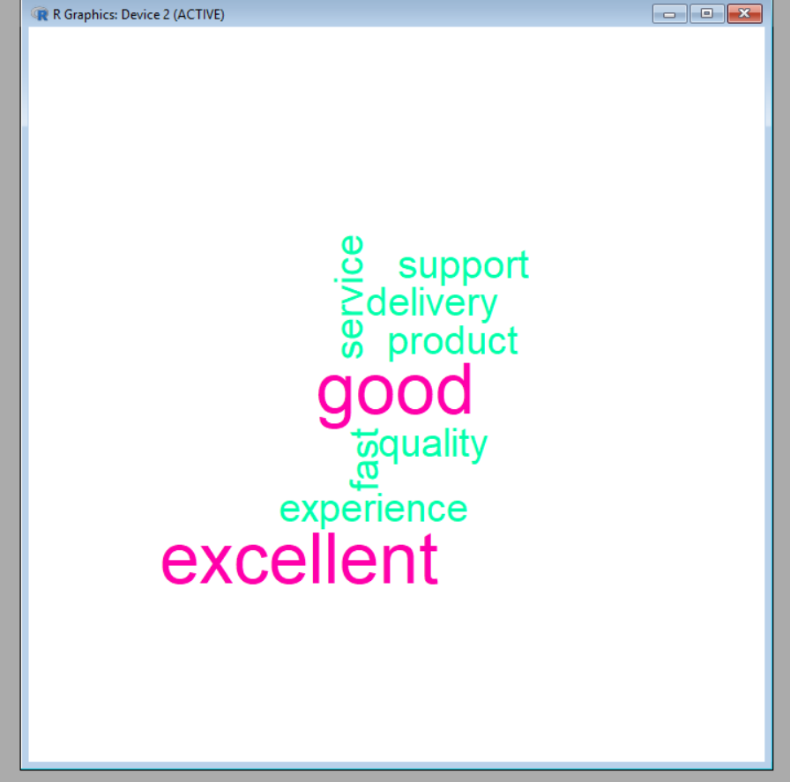
Set 3: Employee Performance Evaluation
Dataset: Employee Performance

- Create a line chart to visualize the performance trend of employees over time. Include a legend and labels.

# Employee Data
employee <- c(1, 2, 3, 4, 5)
performance <- c(85, 92, 78, 90, 76)

# Create Line Chart
plot(employee, performance,
type = "o",
col = "blue",
pch = 16,
lwd = 2,
main = "Employee Performance Trend",
xlab = "Employee ID",
ylab = "Performance Score")

# Add Legend
legend("topright",
legend = "Performance Score",
col = "blue",
lty = 1,
pch = 16)
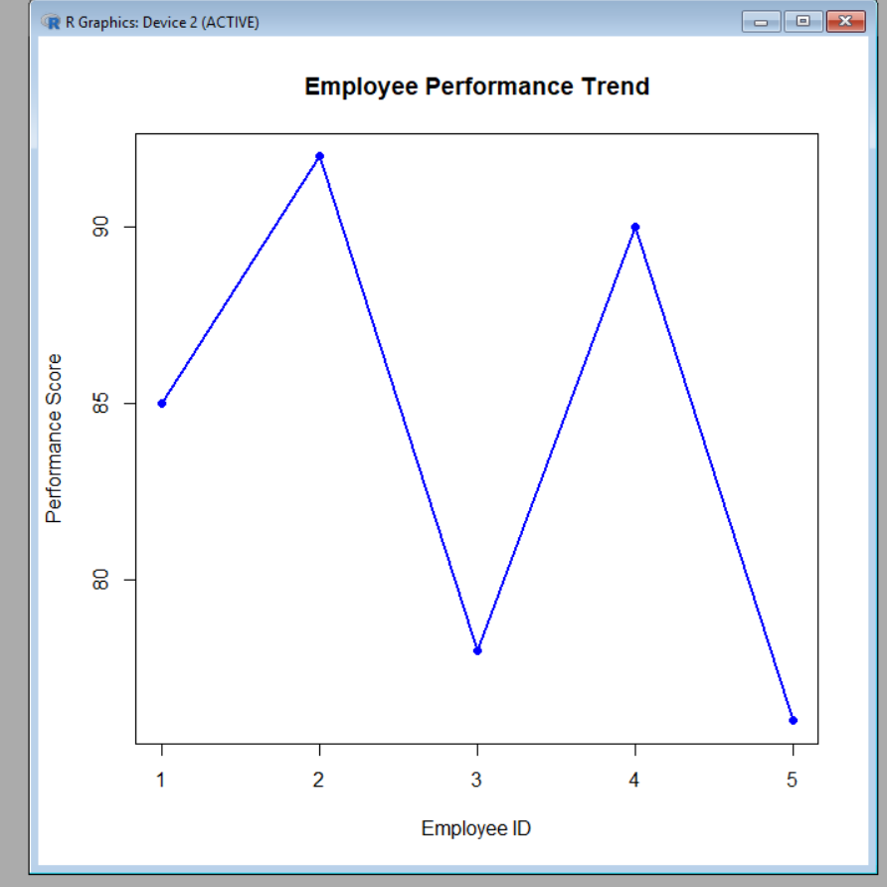

- Generate a bar chart showing the distribution of employees across different departments. Label the chart elements.

# Employee Department Data
department <- c("Sales", "HR", "Marketing", "Sales", "HR")

# Count Employees in Each Department
dept_count <- table(department)

# Create Bar Chart
barplot(dept_count,
main = "Employee Distribution by Department",
xlab = "Department",
ylab = "Number of Employees",
col = c("skyblue", "lightgreen", "orange"),
border = "black")
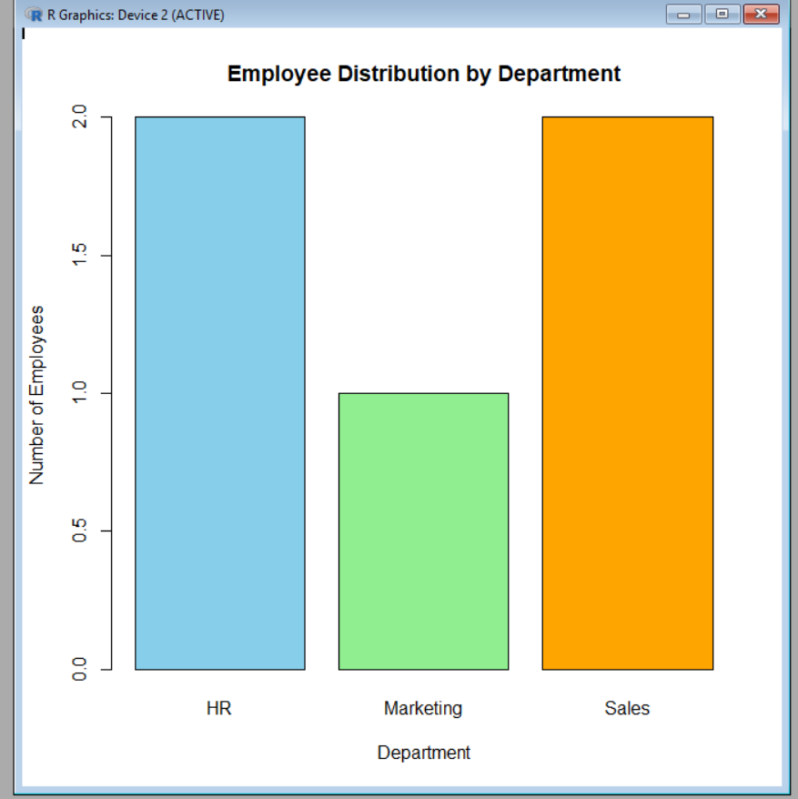

3. Build a scatter plot to analyze the correlation between years of service and performance scores.Explain any insights.

# Employee Data
years <- c(5, 3, 7, 4, 2)
performance <- c(85, 92, 78, 90, 76)

# Create Scatter Plot
plot(years, performance,
main = "Years of Service vs Performance Score",
xlab = "Years of Service",
ylab = "Performance Score",
pch = 16,
col = "blue")

# Add Trend Line
abline(lm(performance ~ years), col = "red", lwd = 2)

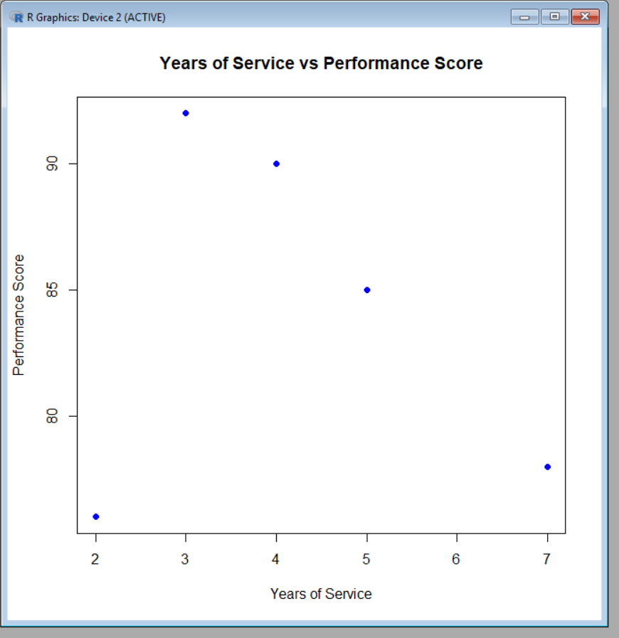

4. Develop a Tableau dashboard with the line chart and bar chart for interactive exploration.

Steps to Create a Tableau Dashboard
- Open Tableau Desktop.
- Import the Employee Performance dataset (Excel/CSV).
- Create the Line Chart:
  - Drag Employee ID to Columns.
  - Drag Performance Score to Rows.
  - Change the Marks type to Line.
  - Add Department to Color to display a legend.
  - Add the title "Employee Performance Trend".
- Create the Bar Chart:
  - Drag Department to Columns.
  - Drag Employee ID to Rows.
  - Change the aggregation to COUNT(Employee ID).
  - Change the Marks type to Bar.
  - Add the title "Employee Distribution by Department".
- Create the Dashboard:
  - Click New Dashboard.
  - Drag the Line Chart and Bar Chart onto the dashboard.
  - Arrange them side by side or one above the other.
- Make it Interactive:
  - Click Dashboard → Actions → Add Action → Filter.
  - Set the Line Chart as the source and the Bar Chart as the target (or vice versa).
  - Enable Use as Filter so selecting a department or employee updates the other chart.
Dashboard Features
- 📈 Interactive Line Chart showing employee performance.
- 📊 Interactive Bar Chart showing employee distribution by department.
- 🔍 Users can click, filter, and explore the employee performance data interactively.

Set 4: Product Inventory Management
Dataset: Product Inventory

1. Create a bar chart to visualize the quantity of each product in the inventory. Label the axes and title the chart.

# Product Inventory Data
product <- c("Product A", "Product B", "Product C", "Product D", "Product E")
quantity <- c(250, 175, 300, 200, 220)

# Create Bar Chart
barplot(quantity,
names.arg = product,
main = "Product Inventory Quantity",
xlab = "Product Name",
ylab = "Quantity Available",
col = "skyblue",
border = "black")
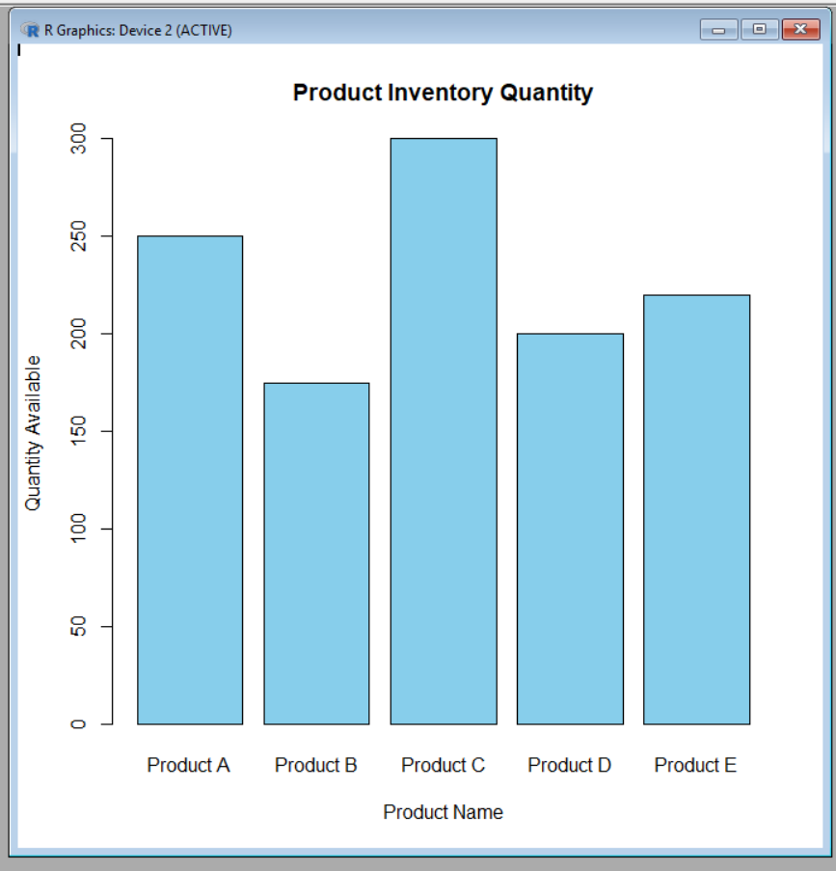

2. Generate a stacked bar chart to show the quantity of each product within different product categories.

# Product Data
product <- c("Product A", "Product B", "Product C", "Product D", "Product E")

# Sample Categories
category <- c("Electronics", "Electronics", "Furniture", "Furniture", "Stationery")

# Quantity Available
quantity <- c(250, 175, 300, 200, 220)

# Create Data Table
inventory <- table(category, product)

# Multiply by quantity to show actual values
inventory[1,1] <- 250
inventory[1,2] <- 175
inventory[2,3] <- 300
inventory[2,4] <- 200
inventory[3,5] <- 220

# Stacked Bar Chart
barplot(inventory,
main = "Product Quantity by Category",
xlab = "Products",
ylab = "Quantity Available",
col = c("skyblue", "lightgreen", "orange"),
legend = rownames(inventory))

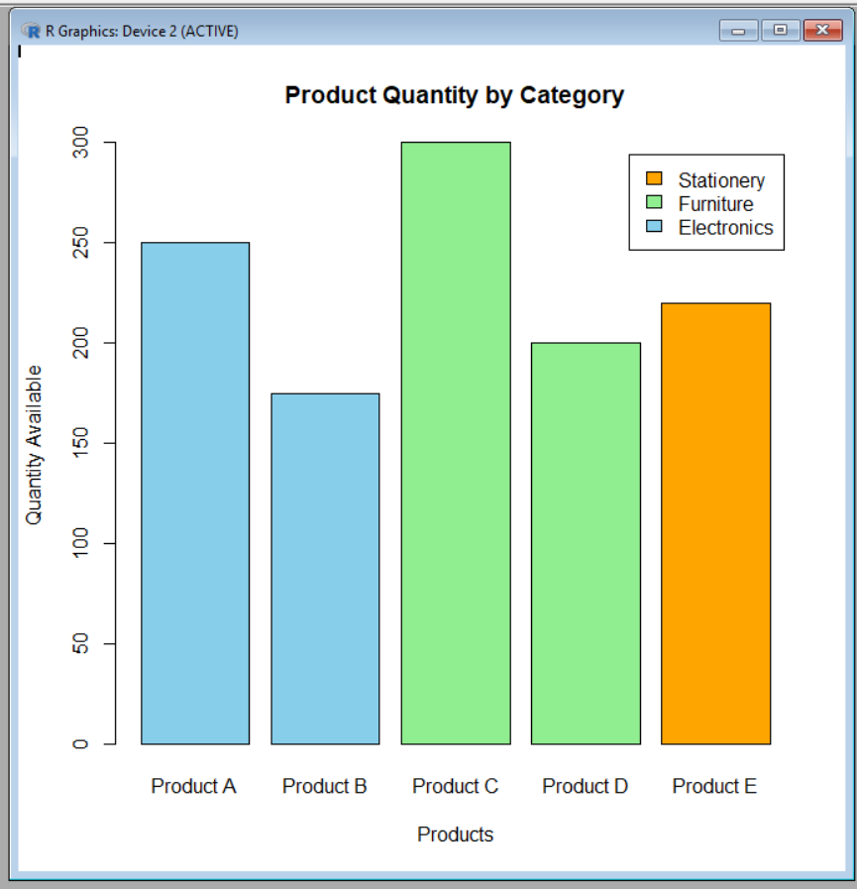

3. Build a scatter plot to explore the relationship between product price and quantity available. Explain the findings.

# Product Data
price <- c(100, 150, 80, 120, 90)
quantity <- c(250, 175, 300, 200, 220)

# Create Scatter Plot
plot(price, quantity,
main = "Product Price vs Quantity Available",
xlab = "Product Price",
ylab = "Quantity Available",
pch = 16,
col = "blue")

# Add Trend Line
abline(lm(quantity ~ price), col = "red", lwd = 2)
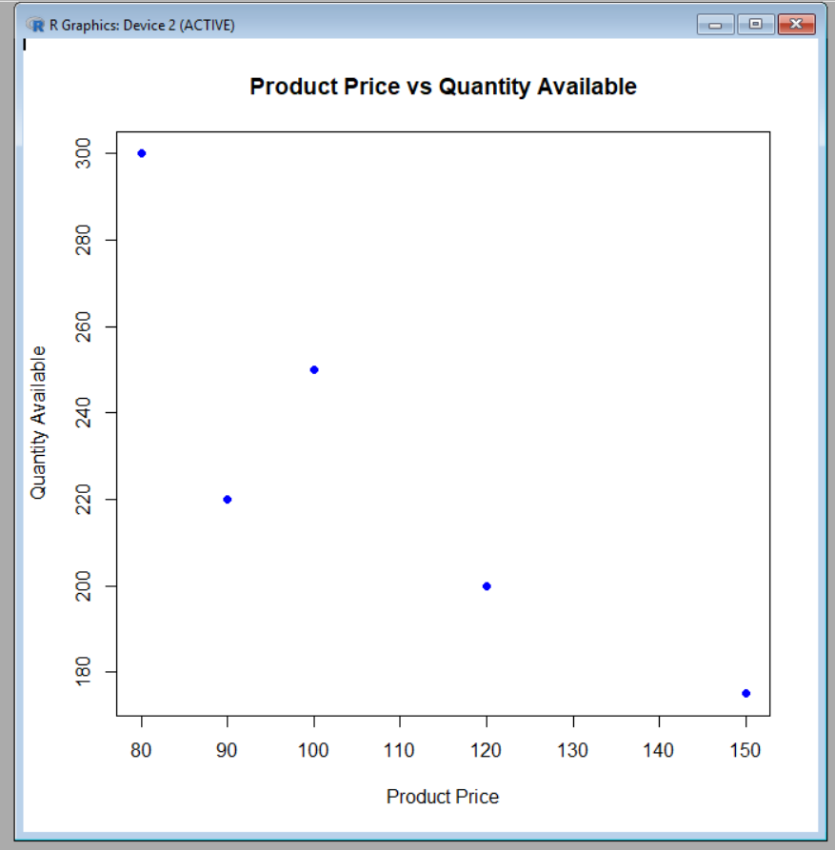

4. Develop a Tableau dashboard with the bar chart and stacked bar chart to allow users to interact with the data.

teps to Create the Dashboard
- Open Tableau Desktop.
- Import the Product Inventory dataset (Excel or CSV file).
Sheet 1: Bar Chart
- Drag Product Name to Columns.
- Drag Quantity Available to Rows.
- Select Bar from the Marks card.
- Add the title "Product Inventory Quantity".
Sheet 2: Stacked Bar Chart
- Drag Product Name to Columns.
- Drag Quantity Available to Rows.
- Drag Product Category (or the sample category field you created) to Color.
- Select Bar from the Marks card.
- Ensure Analysis → Stack Marks → On is enabled.
- Add the title "Product Quantity by Category".
Create the Dashboard
- Click Dashboard → New Dashboard.
- Drag both the Bar Chart and Stacked Bar Chart onto the dashboard.
- Arrange them side by side or one above the other.
Make the Dashboard Interactive
- Click Dashboard → Actions → Add Action → Filter.
- Set one chart as the Source and the other as the Target.
- Enable Run action on Select.
- Users can now click on a product or category in one chart to filter and update the other chart interactively.
Dashboard Features
- 📊 Bar Chart showing Quantity Available for each product.
- 📊 Stacked Bar Chart showing Quantity by Product Category.
- 🔍 Interactive filtering and highlighting.
- 📈 Easy comparison of product inventory across categories.

Set 5: Website Analytics
Dataset: Website Traffic

1. Create a line chart to visualize the trend in daily page views over time. Label the axes and title the chart.

# Website Traffic Data
date <- as.Date(c("2023-01-01", "2023-01-02", "2023-01-03",
"2023-01-04", "2023-01-05"))

page_views <- c(1500, 1600, 1400, 1650, 1800)

# Create Line Chart
plot(date, page_views,
type = "o",
col = "blue",
pch = 16,
lwd = 2,
main = "Daily Page Views Over Time",
xlab = "Date",
ylab = "Page Views")

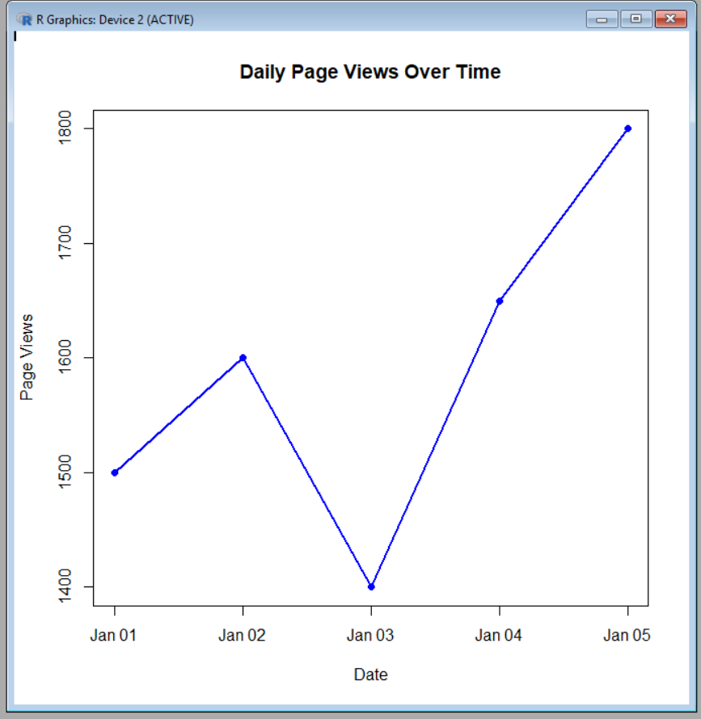

2. Generate a bar chart showing the top N days with the highest click-through rates. Label the chart elements.

# Website Traffic Data
date <- c("2023-01-01", "2023-01-02", "2023-01-03",
"2023-01-04", "2023-01-05")

ctr <- c(2.3, 2.7, 2.0, 2.4, 2.6)

# Select Top 3 Days with Highest CTR
top <- order(ctr, decreasing = TRUE)[1:3]

# Create Bar Chart
barplot(ctr[top],
names.arg = date[top],
main = "Top 3 Days with Highest Click-through Rates",
xlab = "Date",
ylab = "Click-through Rate (%)",
col = "skyblue",
border = "black")

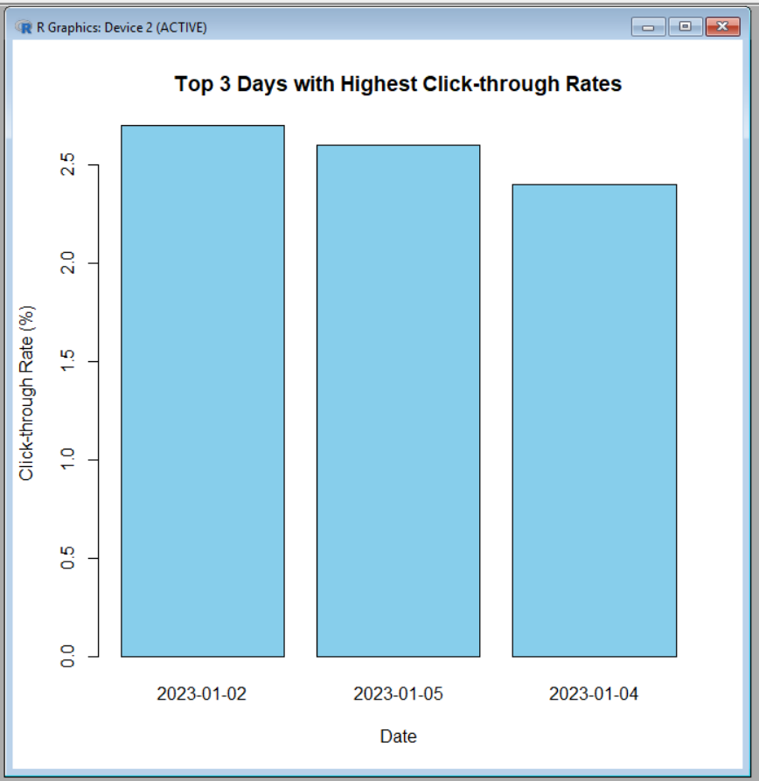

3. Develop a stacked area chart to display the distribution of user interactions (likes, shares, comments) on a website.

# Install package (Run only once)
install.packages("ggplot2")

# Load library
library(ggplot2)

# Install package (Run only once)
install.packages("reshape2")

# Load library
library(reshape2)

# Website Interaction Data
date <- c("2023-01-01","2023-01-02","2023-01-03",
"2023-01-04","2023-01-05")

likes <- c(100,120,110,130,140)
shares <- c(40,45,35,50,55)
comments <- c(20,25,18,30,28)

# Create Data Frame
data <- data.frame(date, likes, shares, comments)

# Convert to Long Format
data_long <- melt(data, id.vars = "date")

# Create Stacked Area Chart
ggplot(data_long,
aes(x = date, y = value, fill = variable, group = variable)) +
geom_area() +
labs(title = "User Interactions on Website",
x = "Date",
y = "Number of Interactions") +
theme_minimal()

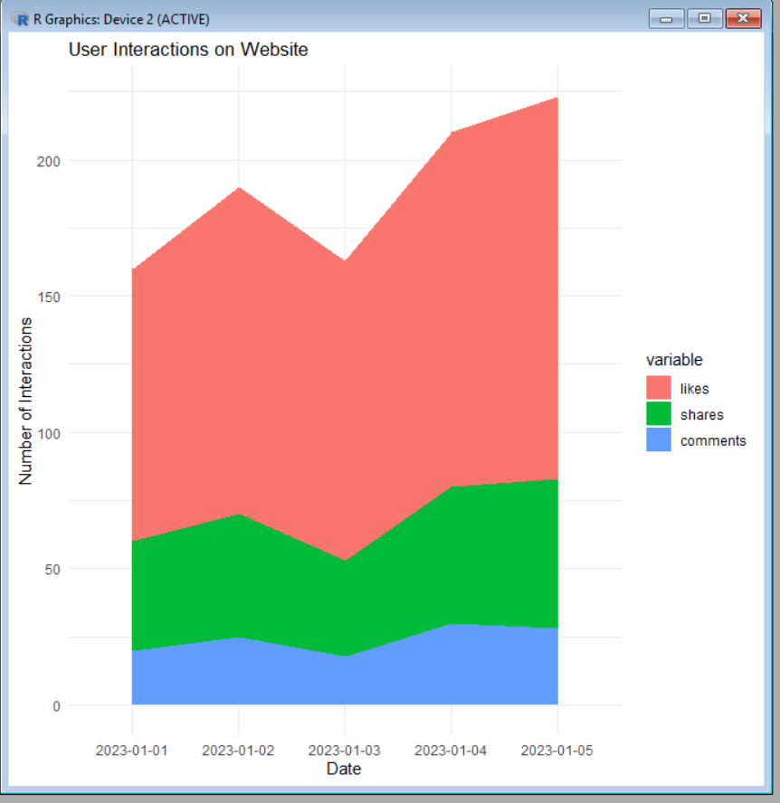

4. Build a Tableau dashboard with the line chart and bar chart for interactive exploration of website
traffic data.

Steps to Create the Dashboard
- Open Tableau Desktop.
- Import the Website Traffic dataset (Excel/CSV).
Sheet 1: Line Chart
- Drag Date to Columns.
- Drag Page Views to Rows.
- Set the Marks type to Line.
- Add the title "Daily Page Views Over Time".
Sheet 2: Bar Chart
- Drag Date to Columns.
- Drag Click-through Rate (CTR) to Rows.
- Set the Marks type to Bar.
- Add the title "Top Click-through Rates by Date".
Create the Dashboard
- Click Dashboard → New Dashboard.
- Drag both the Line Chart and Bar Chart onto the dashboard.
- Arrange them side by side or one above the other.
Make the Dashboard Interactive
- Click Dashboard → Actions → Add Action → Filter.
- Choose the Line Chart as the source and the Bar Chart as the target (or vice versa).
- Select Run action on Select.
- Now, clicking on a date in one chart filters and updates the other chart automatically.
Dashboard Features
- 📈 Interactive Line Chart showing daily page views.
- 📊 Interactive Bar Chart showing click-through rates.
- 🔍 Interactive filtering and highlighting.
- 📅 Easy exploration and comparison of website traffic across different dates.

Set 6
Product Sales Analysis
Dataset: Monthly Product Sales

1. Create a grouped bar chart to visualize the sales of each product for the first quarter. Label the chart elements.

# Product Sales Data
sales <- matrix(c(2000,2200,2400,
1500,1800,1600,
1200,1400,1100),
nrow = 3, byrow = TRUE)

# Product Names
rownames(sales) <- c("Product A", "Product B", "Product C")

# Quarter Months
colnames(sales) <- c("January", "February", "March")

# Create Grouped Bar Chart
barplot(sales,
beside = TRUE,
col = c("skyblue", "lightgreen", "orange"),
main = "First Quarter Product Sales",
xlab = "Months",
ylab = "Sales",
legend.text = rownames(sales))
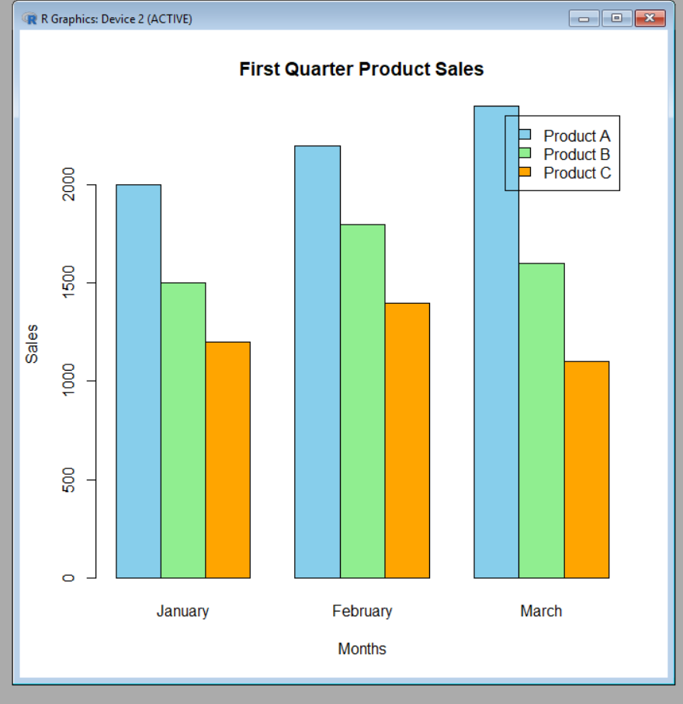

2. Generate a stacked area chart to represent the overall sales trend for all products over the three months.

# Install packages (Run only once)
install.packages("ggplot2")
install.packages("reshape2")

# Load libraries
library(ggplot2)
library(reshape2)

# Sales Data
sales <- data.frame(
Month = c("January", "February", "March"),
Product_A = c(2000, 2200, 2400),
Product_B = c(1500, 1800, 1600),
Product_C = c(1200, 1400, 1100)
)

# Convert data to long format
sales_long <- melt(sales, id.vars = "Month")

# Create Stacked Area Chart
ggplot(sales_long,
aes(x = Month, y = value,
fill = variable, group = variable)) +
geom_area() +
labs(title = "Overall Sales Trend for All Products",
x = "Month",
y = "Sales") +
theme_minimal()

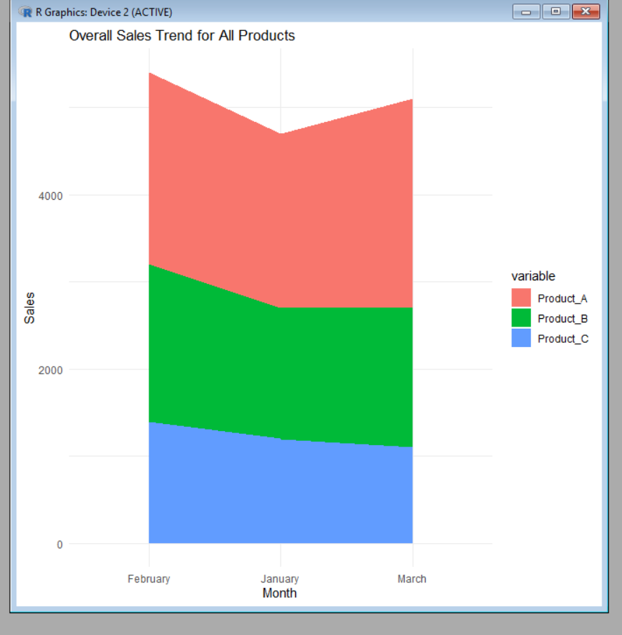

- Build a table to show the monthly sales data for each product. Label the table elements.

# Product Sales Data
sales <- data.frame(
Product = c("Product A", "Product B", "Product C"),
January = c(2000, 1500, 1200),
February = c(2200, 1800, 1400),
March = c(2400, 1600, 1100)
)

# Display Table
print("Monthly Product Sales Table")
print(sales)

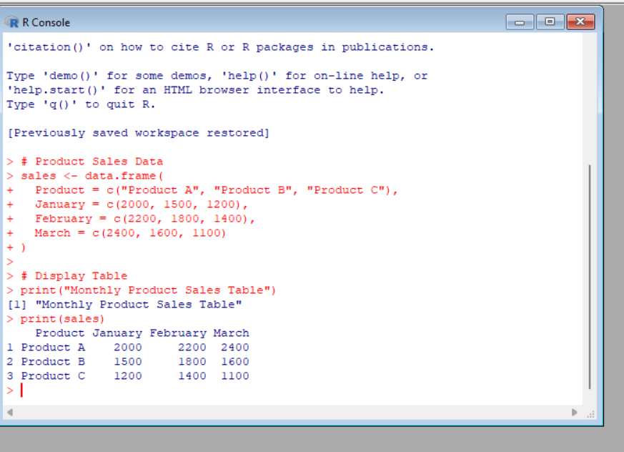

4. Develop a Tableau dashboard combining the grouped bar chart, stacked area chart, and the table for interactive exploration of sales data.

Steps to Create the Dashboard
- Open Tableau Desktop.
- Import the Monthly Product Sales dataset (Excel/CSV).
Sheet 1: Grouped Bar Chart
- Drag Month to Columns.
- Drag Sales to Rows.
- Drag Product Name to Color.
- Select Bar from the Marks card.
- Add the title "First Quarter Product Sales".
Sheet 2: Stacked Area Chart
- Drag Month to Columns.
- Drag Sales to Rows.
- Drag Product Name to Color.
- Change the Marks type to Area.
- Ensure Analysis → Stack Marks → On is enabled.
- Add the title "Overall Sales Trend".
Sheet 3: Sales Table
- Create a new worksheet.
- Drag Product Name to Rows.
- Drag January Sales, February Sales, and March Sales to Text.
- Add the title "Monthly Product Sales Table".
Create the Dashboard
- Click Dashboard → New Dashboard.
- Drag the Grouped Bar Chart, Stacked Area Chart, and Sales Table onto the dashboard.
- Arrange them neatly for easy viewing.
Make the Dashboard Interactive
- Click Dashboard → Actions → Add Action → Filter.
- Set any chart as the Source and the other charts/table as the Target.
- Choose Run action on Select.
- Clicking on a product or month in one visualization updates the others automatically.
Dashboard Features
- 📊 Grouped Bar Chart to compare product sales across months.
- 📈 Stacked Area Chart to show the overall sales trend.
- 📋 Sales Table displaying monthly sales values.
- 🔍 Interactive filtering, highlighting, and comparison of product sales data.

